CME1001 Algorithms and Programming I
LAB 2

VISUAL STUDIO ENVIRONMENT

Visual Studio: Platform to create, run, and debug programs

STEP 1. Open Visual Studio 2015, 2013, 2012 or 2010 from start menu

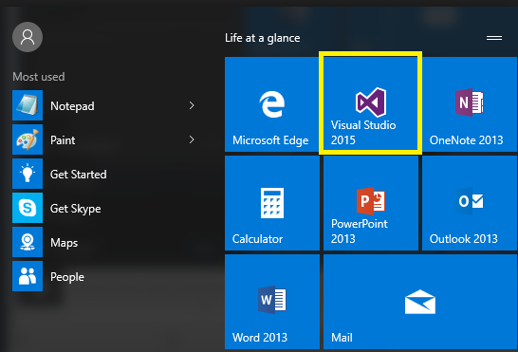

STEP 2. Create a New → Project by clicking on File menu

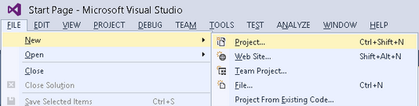

Select Visual C# from left window and Console Application from the right window.

Write a project name, for example MyFirstProgram.

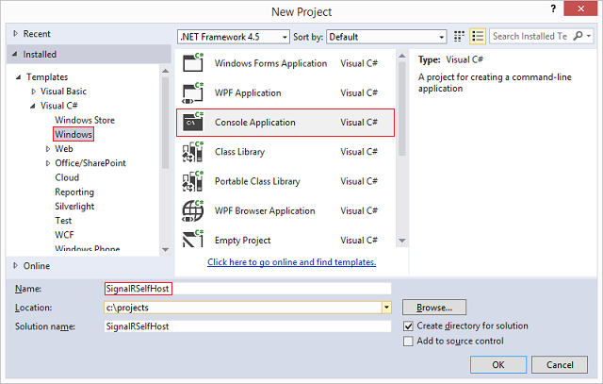
Write a Project Name
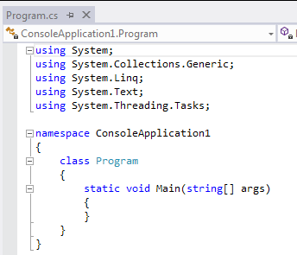
Write your code here

STEP 3. Write your code.

Console.WriteLine("Welcome!!!");
Console.ReadLine();

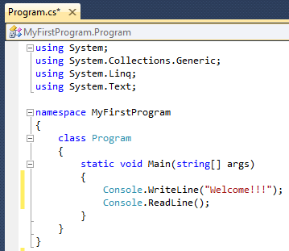

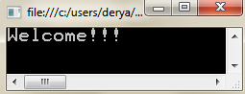
STEP 4. Execute your program.

Start(F5) Pause Stop

Syntax Errors, Error Messages and the Error List Window

  - Syntax Error: A violation of Visual C# rules for creating correct application
  - Error List Window: Window where the descriptions of the errors are located

Note: Red underline indicts a syntax error

Red underline indicates a syntax error

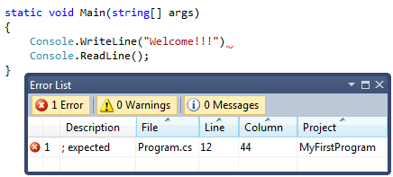

Error descriptions

Error List Window

EXECUTE AN EXAMPLE CODE

What is the output of the following code?

Copy paste the following example program, execute them and understand the result.

int number1; // declare first number to add
int number2; // declare second number to add
int sum; // declare sum of number1 and number2

Console.Write( "Enter first integer: " ); // prompt user
number1 = Convert.ToInt32( Console.ReadLine() ); // read first number from user

Console.Write( "Enter second integer: " ); // prompt user
number2 = Convert.ToInt32( Console.ReadLine() ); // read second number from user

sum = number1 + number2; // add numbers

Console.WriteLine( "Sum is " + sum ); // display sum
Console.ReadLine();

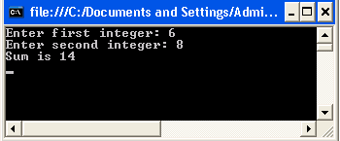

Exercises

1- Write a program that takes a number (X) from the user and then prints the value of the following items:

|X| e^{X} П/3X
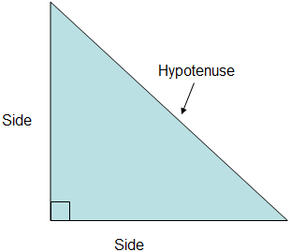

2- Write a program that takes the lengths of two sides and finds the hypotenuse of the right triangle.

Inputs: 7.1 and 12.5
Output: 14.376


3- Write a program that converts a measurement given in cubic meters (m³) to the equivalent number of cubic feet (ft³), cubic yard (yd³) and cubic decimeter (dm³).

4- Write a program that reads an integer between 1 and 99, then adds the digits in the integer.
For example, if an integer is 93, the sum of its digits is 12.

5- There are approximately 3,156 x 107 seconds in a year.
Draw a program that takes an age in years (from the user) and then prints the equivalent number of seconds.

Example:
Input: 18
Output: 6,078,456

6- Assume that we have nested equilateral triangles.
An inner triangle is constructed by three midpoints of the sides of outer triangle.

Write a program that takes the length of the side of the largest (outmost) triangle (a) from the user and prints the area of the black shape.

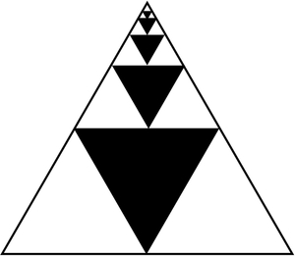

a

Example:
Input: 1.53
Output: 0.333

Questions

Upload the answers of the following questions from http://lectures.cs.deu.edu.tr web site until October 11, 2015, 23:55.

Upload only a single cs file which was named by your Number_Name_Surname, such as 2015510120_Ali_Tas.cs


1- Write a program which that takes the values of a, b and x from the user and calculates the result of the following mathematical formula:


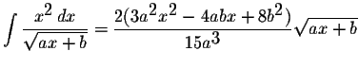
Example:
Input: a=2 b=1 x=4
Output: 8.4

2- Write a program that takes the length of the square from the user and prints the area of the black shape.



3- Write a program that takes geographical Latitude information (in decimal format) from the user and then:
- converts it to degree / minute / second format
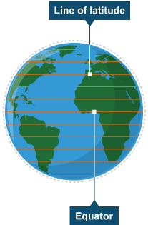
- finds the distance from the equator.

Decimal  Degrees | Degree Minute Second (DMS) | explanation | N/S or  E/W at equator
1.0 | 1° 00′ 0″ | country or large region | 111.32 km
0.1 | 0° 06′ 0″ | large city or district | 11.132 km
0.01 | 0° 00′ 36″ | town or village | 1.1132 km

Example:
Input: 50.56
Output: degree = 50°
minute = 33'
second = 36"

distance = ~ 5628 km

4- Write a program that takes three integers – Red, Green, and Blue (RGB) - from the user and print the equivalent YUV. In other words, the program should convert from RGB to YUV .
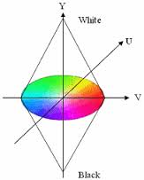
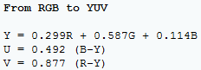


5- Write a “units of conversion” program. The program should convert the distance given in Meter to the equivalent number of
a) Rods b) Pica c) Thou
6- Write a program that prints your name and your picture by using ASCII characters.

Examples:
DD EEEE RR Y Y A
D D E R R Y Y A A
D D EEE RR Y AAAAA
D D E R R Y A A
DD EEEE R R Y A A

